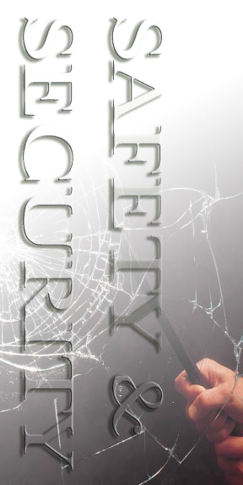

SAFETY AND SECURITY

Building Features for Safety and Security

Safety and Security

Security
The main Security station for the Mission Bernal Campus is located on the 2nd floor at the 27th Street Main Entrance / ED Entrance. Security enhancements include a metal detector at the Emergency Department entrance. Panic alarms are located in identified high risk areas; when activated, a silent alarm is sent to Security Dispatch. Security stations are located at key main entrances to include the ED, and Loading Dock. Security Dispatch phone number is 415-600-0837 (ext. 60837).
Security Awareness:
Be aware of your surroundings
For emergency situations (other than Code Blue) dial 4-4444
Keep your personal property especially purses, briefcases and bags locked and secure
If you see something – say something
Pay attention to person who look suspicious or look like they don’t belong
Make sure vendors have a vendor badge
Be alert when you are in areas or around people that are unfamiliar to you
If you wish for an escort to your vehicle, contact Security Dispatch x60837
For general Security concerns, contact Security Dispatch at x60837

RESPONDING TO A CODE BLUE OR OTHER MEDICAL EMERGENCY

If you witness a patient, visitor or staff member who is in cardiac and/or respiratory distress, or having a medical emergency, immediately seek medical-nursing assistance by calling for help – and by dialing 5-5555 from a hospital phone. Patient Care areas should also use the Code Blue alarm system, but also need to alert the hospital Operator by dialing 5-5555.
For other types of urgent medical situations (Rapid Response) and non-medical emergencies (Code Red, Code Gray, etc.), dial 4-4444 from an in-house phone, provide nature of emergency, your name and location.

Code Team
The Code Team will respond to all patient medical emergencies in the main hospital and will respond to non-patient emergencies only if requested Code Blue is called. The Code Team is multi-disciplinary, made up of ICU MD’s, RN’s, Respiratory Therapist(s), Security, and a Nursing Supervisor.

Emergency Department (ED) Team
The ED team will respond to all non-patient emergencies in the main hospital.

Crash Carts
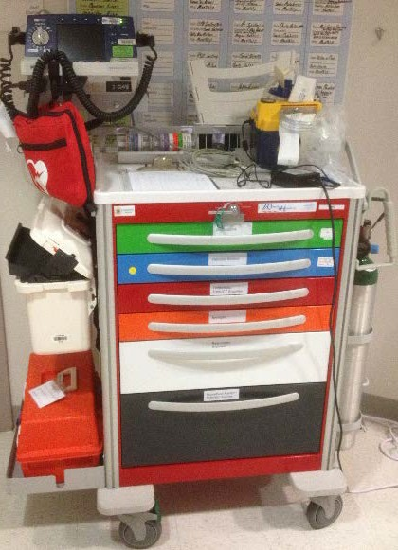
In the event of a medical emergency for patients, visitors or staff, Crash Carts are strategically located throughout the Mission Bernal Campus.

Figure 2: Typical Crash Car
AED’s
There are two AED’s located outside the MBC L1 Main Conference Room and Cafeteria.
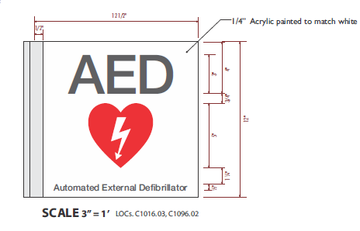
Emergency Management
Emergency Operations Plan
Emergencies, disasters and other catastrophic events pose a significant threat to the ability of a healthcare organization to maintain operational capability and provide care, treatment, and services to its community.
California Pacific Medical Center (CPMC) has implemented a comprehensive all hazards Emergency Operations Plan in order to assure the most appropriate hospital response to the medical needs of the community, in the event of an emergency/disaster situation or a mass casualty incident. This is an organization-wide program that incorporates all services and sites of care under our license. This plan applies to staff, licensed independent practitioners, contract workers, volunteers and others as appropriate and indicated throughout this document.
This all hazards program complies with the elements of the National Incident Management System (NIMS) and incorporates the Hospital Incident Management System (HICS) and addresses the six critical areas mandated by Joint Commission standards. Those six critical areas are communications, resources and assets, safety and security, staff responsibilities, utilities management, and patient clinical and support activities.
The full plan is located on the CPMC Intranet

Hospital Command Center
The hospital uses the Hospital Incident Command Structure (HICS) to manage emergency events and if the situation warrants the Emergency Operations Plan would be activated via Code Triage. If Code Triage is initiated, the Hospital Command Center (HCC) will be activated and is located on the First Floor, Conference Room A&B, if additional resources are needed to manage the event, the Labor Pool will be activated and is located in the hospital cafeteria.
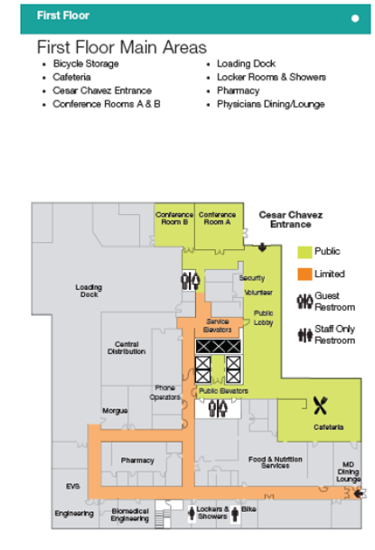

Communications in a Disaster
The Sutter System affiliates use Everbridge Mass Notification System to communicate to all staff simultaneously in a disaster or other type of emergency situation. With a system-wide notification system, CPMC can ensure staff receive and respond to critical safety and business impact information in a timely manner.
Everbridge allows CPMC to communicate with employees via multiple contact paths including home phone, email, mobile phones and other communication devices during an emergency event.
What to do when a notification is received: Read (when received via email) or listen to the message carefully for directions; when asked to “confirm the message”, click on the link provided in the email, or “press 1” if the message is received via phone. The purpose of confirming the message is so that CPMC knows that you have received the message.
Everbridge has been implemented to improve the efficiency and effectiveness of communications.
Having accurate contact information is critical for Everbridge to work effectively and for you to receive emergency information. In some cases, personal contact information such as cell and home are inaccurate or missing in Lawson. Please check your personal profile to confirm the information is accurate and up to date.
How to update your personal contact information: Please ensure all of your personal contact information is up to date by checking the Lawson e-Self Service site on the Intranet Portal. Everbridge pulls from Lawson and unless your personal information is accurate you may not receive emergency notifications.
Questions regarding Everbridge should be directed to the Safety Department

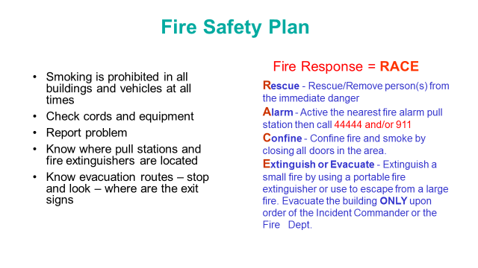

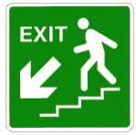
General Fire Safety
- If the fire alarm is activated make sure corridors are clear.
- During an actual fire or smoke event, do not use elevators. Follow exit signs to the nearest, safest exit stairwell.
- Do not open doors if they are hot to touch, or if you can see smoke. If you become trapped in a room, and cannot exit safety, keep the door closed and seal off any cracks. Call hospital operator at 4-4444 and report your exact location.
- If a door feels cool to the touch, open it cautiously. Be prepared to slam the door shut if the corridor is full of smoke or if you feel heat when opening the door. If the corridor is clear, proceed with evacuation.
- If you are caught in smoke or heat, stay low until you reach a safe area such another smoke compartment.

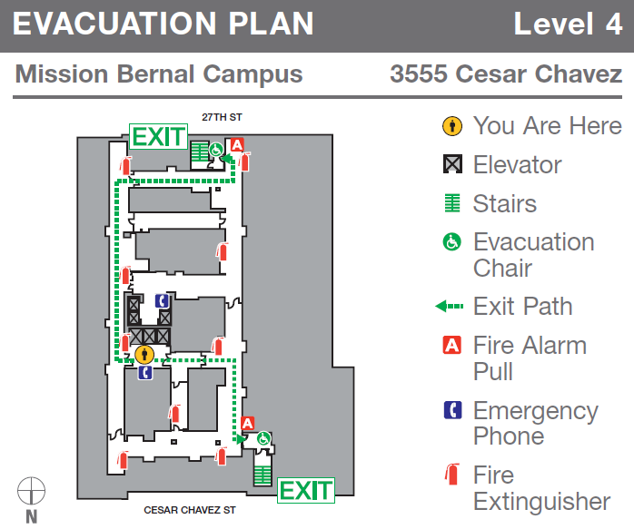
Evacuation Plan as shown below are located on each floor

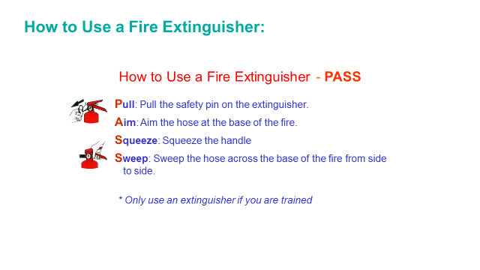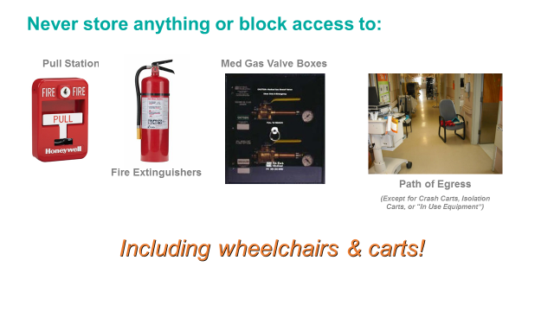
No storage in corridors with the exception of Crash Carts, Isolation Carts in Use and Patient Mobilization Equipment (lifts)

NEW STANDARDIZED EMERGENCY CODES
Emergency Code |  | Definition and Announcement
CODE BLUE  - Adult  - Maternity  - Pediatric  - V.A.D. | Cardiac or respiratory arrest  ANNOUNCEMENT: "Code Blue (Adult, Maternity, Neonate, Pediatric, or V.A.D.) - location"
CODE GRAY | Combative Person (aggressive, hostile, combative or potentially combative persons)  ANNOUNCEMENT: "Code Gray - location"
CODE ORANGE | Hazardous Material Spill/Release  ANNOUNCEMENT: "Code Orange - Hazardous Materials Spill/Release -  location"
CODE PINK | Infant Missing or Abducted (infants/children up to 2 years of age) ANNOUNCEMENT: "Code Pink last seen - location insert description (e.g. age, gender, race,) of missing infant and description (e.g. age, gender, race, clothing) of individual that may be with, if available."
CODE PURPLE | Child/Adult Missing or Abducted (child/adult over the age of 2) ANNOUNCEMENT: "Code Purple (child or adult) - last seen - location and description (e.g. age, gender, race, clothing)"
CODE RED | Fire  ANNOUNCEMENT: "Code Red - location"
CODE SILVER | Person with a Non-firearm Weapon and/or Hostage Situation ANNOUNCEMENT: "Code Silver - location. A security threat exists at location. All persons should immediately move away from that location if it is safe to do so. If it is not safe to move away, seek shelter or remain in a room with the door closed until an all clear has been announced."
Code Silver - ACTIVE SHOOTER | ANNOUNCEMENT: "Code Silver - active shooter - location. A security threat involving a firearm exists at location. All persons should immediately move away from that location if it is safe to do so. If it is not safe to move away, seek shelter or remain in a room with the door closed until an all clear has been announced."
CODE LIME | Electronic health record is down.  ANNOUNCEMENT: "Code Lime - initiate (EPIC, PACS, other) downtime procedures."
CODE SEPSIS | A patient is in septic shock and needs emergent attention. ANNOUNCEMENT: "Code Sepsis - location."
CODE TRIAGE, INTERNAL/ EXTERNAL ALERT/ ACTIVATE | Disaster/MCI/patient surge event. Activate Emergency Operations Plan for internal or external incident.  ANNOUNCEMENT: "Code Triage Internal/External – Alert – situation*." OR "Code Triage Internal/External – Activate – situation*. The emergency operations plan has been activated" When applicable the following should be added to the announcement: "Incident management team members should proceed to the location for a briefing."  *NOTE: Plain language should be used to describe the "situation." For
CODE YELLOW | Bomb Threat (a bomb threat or the discovery of a suspicious device or item) ANNOUNCEMENT: "Code Yellow - location."

Medical Alerts | Definition and Announcement
C-SECTION | A pregnant patient needs an emergent C-section. ANNOUNCEMENT: "Medical Alert: C-section - location."
ECMO | A patient needs emergent extracorporeal life support. ANNOUNCEMENT: "Medical Alert: ECMO (infant, child, or adult) - location."
IMMINENT DELIVERY | A pregnant patient in advanced stages of labor cannot be transported to the Labor & Delivery Unit prior to delivery and needs emergent attention. ANNOUNCEMENT: Medical Alert: Imminent Delivery - location."
MASSIVE BLOOD TRANSFUSION | A patient emergently needs a massive blood transfusion. ANNOUNCEMENT: "Medical Alert: Massive Blood Transfusion - location."

RAPID RESPONSE | A patient with early signs of clinical deterioration needs emergent attention to prevent respiratory or cardiac arrest.  ANNOUNCEMENT: "Medical Alert: Rapid Response - location."
SEPSIS | A patient has severe sepsis and needs urgent attention. ANNOUNCEMENT: "Medical Alert - Sepsis - location."
STEMI | A patient with myocardial infarction and ECG evidence of ST elevation needs emergent percutaneous coronary intervention.

Code Gray
Will be initiated for any event with aggressive, hostile, combative, or potentially combative behavior from a patient, visitor, or staff member, without the display of weapons.

Response Procedures
At the first indication of a perceived Code Gray:
- Dial the emergency number 4-4444
- Describe the incident to the operator, including the specific location
- Security will determine when an “All Clear” will be announced.

Post Incident:
- Security will conduct a post investigation debriefing. You will be interviewed to gather incident specific information.
- Complete the Workplace Violence Incident Report and, if applicable, an electronic Report of Injury (eRO), Patient Safety Report (PSR) and Quality Risk Assessment.
Infant Security:
There is an Infant Security System installed in Women’s’ and Infants Center (Labor & Delivery, Nursery, NICU & Pediatrics) to protect our infants and prevent infant abductions. Code Pink and Code Purple are used in the event of a missing infant or child.

Code Pink
Is initiated when an infant/child less than 2 years of age is discovered missing or has been abducted.
Staff response to a missing or abducted infant/child.

Staff response to a missing or abducted infant/child
- Call the emergency number (4-4444) the moment an infant/child is confirmed missing or abducted
- State an infant/child is missing or abducted and provide:
- Your name and the location where the infant/child was last seen;
- The infant/child’s name and physical description (age, gender, race, etc.)
- Any additional details about the abduction or absence (e.g. description of the abductor)

Staff Response to a Code Pink Announcement
- Immediately stop all non-critical work and proceed to your department’s pre-assigned area(s) to observe stairwell door, elevator areas and exit doors. If outside of your department, monitor the nearest exit. Continue monitoring until “Code Pink” – All Clear” is announced.
- Identify and report suspicious individual(s) to the emergency number (4-4444).
- Respectfully engage anyone who is carrying an infant or may be concealing an infant. Explain the situation and request to inspect objects.
- If the suspected abductor flees, do not forcibly restrain them. If safe to do so, follow them taking note of their appearance, what they are wearing and how the exit the building.
- If the suspect abductor reaches the parking lot and attempts to leave by car, take note of the vehicle’s make, model, color and license plate.
Code Purple
Is initiated when a child/adult over the age of 2 is discovered missing or has been abducted.
Staff should initiate a “Code Purple” when the missing child/adult:
- Is a minor;
- May have been removed from the facility against their will:
- Has a central line, IV, PICC Line, catheter, etc.;
- Is awaiting Psychiatric Emergency Service evaluation;
- Poses a danger to themselves or others as documented by physician;
- Is on a conservatorship;
- Anytime a clinician has concerns with the patient leaving the facility
Staff response to a missing or abducted child/adult:
- Call the emergency number the moment a child/adult is confirmed missing or abducted.
- State a child/adult is missing or abducted and provide:
- Your name and the location where the infant/child was last seen;
- The infant/child’s name and physical description (age, gender, race, etc.)
- Any additional details about the abduction or absence (e.g. description of the abductor)

Staff response to a Code Purple Announcement:
- Immediately stop all non-critical work and proceed to your department’s pre-assigned area(s) to observe stairwell doors, elevator areas and exit doors. If outside of your department, monitor the nearest exit. Continue monitoring until “Code purple – All Clear” is announced.
- Identify anyone matching the description of the missing child/adult and call the emergency number.
- Respectfully engage anyone who is carrying a child or may be concealing a small child. Explain the situation and request to inspect small objects.
- Identify anyone in obvious distress (struggling, needing assistance, appearing lost/confused, etc.) and call emergency number.
- If the suspect flees, do not forcible restrain them. If safe to do so, follow them taking note of their appearance, what they are wearing and how the exit the building.
- If the suspect abductor reaches the parking lot and attempts to leave by car, take note of the vehicle’s make, model, color and license plate.

What do you do if you get injured?
Employees are required to report all work-related injuries and/or illnesses to their supervisor or the on-duty supervisor immediately and complete an Electronic Report of Injury Form (eROI) by the end of shift in which the injury or illness occurred. The forms are located on the CPMC Intranet under Frequently Reviewed Forms – Environment of Care.
Upon completion and submission of the form, an incident analysis will be completed by the employee’s manager to determine what caused the incident and actions needed to be taken to prevent the incident from reoccurring.

Workplace Violence Reporting
Effective April 1, 2017, employees working in inpatient and outpatient settings and clinics on hospital licenses are required to report workplace violence incidents into the Midas Workplace Violence Incident Report.
Adopted on October 20, 2016, certain healthcare facilities as defined by the new Cal/OSHA Workplace Violence Prevention Plan standards, Section 3342, California Code of Regulations Title 8, are required to maintain a log of all incidents of workplace violence by April 1, 2017.
The purpose of the new standard is to protect employees, physicians, volunteers, and contracted personnel from aggressive and violent behavior. For example, physical and/or verbal assault, sexual assault, threats, and violation of a restraining order.
In addition, if an employee is injured in a workplace violence incident they must complete an Electronic Report of Injury (eROI) Form AND a Workplace Violence Incident Report.
If a patient is injured, the employee must go to the Hospital Midas Tools Page and complete a patient injury form.
Safety, security, human resources, risk management, and operations management will coordinate a post incident investigation.

Equipment and Furnishings

Ergonomics
Ergonomic chairs and keyboard trays are standard features of the new Mission Bernal Campus. The chairs and keyboard trays are fully adjustable.
For assistance on proper chair and keyboard adjustment, please contact Safety Management. They will send materials regarding self-assessments and if needed will direct you to complete the on-line ergonomic assessment.

MRI Safety

RISKS ASSOCIATED WITH MAGNETIC RESONANCE IMAGING (MRI)
The Missile Effect
The missile effect or projectile effect refers to the capability of the fringe field of the static magnetic field to attract a ferromagnetic object, drawing it rapidly into the scanner with considerable force. When this occurs, the missile effect can pose a significant risk to anyone in the path of the projectile, and cause significant damage to the scanner.
To guard against accidents from metallic projectiles, the 5 gause line should be clearly demarcated and the area with that line kept free of ferromagnetic objects. Personnel and research participants must remove all metallic personal belongings (hearing aids, analogue watches, jewelry, belts, etc.) before entering the magnet room, as well as any clothing with magnetic fasteners.
All equipment to be taken into the scanner room, housekeeping supplies (bucket, broom, mop, etc), research equipment (props), tools, and emergency equipment (fire extinguisher, etc) must be made of non-ferrous material and be classified as MR safe

MRI Safety Zones:
The area where the MR scanner is housed is divided into four safety zones in accordance with the ACR Guidance for Safe MR Practices 2007 .
- Zone I is the zone furthest from the magnetic field, open to the Public.
- Zone II indicates the interface between publicly accessible Zone I and the restricted Zones III & IV. The MRI screening room where patients are greeted and screened before entering the scanner room is Zone II.
- Zone III is the region in which free access by un-screened non-MR personnel or ferromagnetic objects or equipment can result in serious injury or death. Zone III is strictly restricted! The MRI console and MRI equipment Room are Zones 3a and 3b, respectively.
- Zone IV is synonymous with the MR scanning laboratory, that is, the physical confines of the room within which the M scanner is located. The 5 gauss line extends into the console room (Zone 3A) along the wall shared with Zone IV, and is clearly marked with tape. This is the area where screened MRI patients, hospital employees and vendors, etc are under constant direct supervision of trained MRI Technologists only. You will see caution signs posted and a red line at the edge of this zone.

MRI Security and Access
Unauthorized access to the MRI Suite and scanner magnet can result in injury to those who may have conditions that are unsafe for the MR environment, damage to personal items that can be affected by the magnetic field, and damage to the scanner resulting from a ferromagnetic object being pulled into the bore of the magnet. For this reason, the MRI Suite is a restricted room.
Access to the MRI Suite is limited to MRI personnel and Security and is controlled with a manual key. Unsupervised access is restricted to those individuals certified to operate the scanner and those who may need to enter the console, equipment and scanner rooms in the event of an incident or emergency. No one is permitted supervised or unsupervised access without appropriate notification of the potential risks associated with the magnet. Keys to the MRI Suite must be kept in a secure location and cannot be shared or loaned to other personnel.
All individuals, visitors, Field Service Engineers, etc are all screened and supervised by the MRI Technologist

ADA Information

Assistance for the Hearing, Listening, Visually and Speech Impaired

- MySutter Portal: Interpreter Services & Multilingual Resources http://mysutter/SHWBR/CPMC/Resources/MoreResources/Pages/InterpreterServices.aspx
- For American Sign Language Interpreter Services, (sign language only, not languages such Spanish, Chinese, etc.) To schedule an ASL interpreter
  - use the Online Interpreter Scheduling system or
  - call our ASL vendor at 1-800-975-8150

- For Assistive Listening Systems (Pocket Talkers), Call Campus Security at 415-600-0837 or ext. 60837
- For an Amplified Telephone Handset, call 74000 or 888-888-6044
- Closed caption decoders - Closed captioning is text that scrolls on a television screen so that an individual who cannot hear the content can read the text of the audio content. The televisions located in the [reception/visitor waiting areas, patient rooms] are equipped with Closed Caption features. The Closed Caption feature is available in every patient room and can be activated by pressing the Pillow Speaker “CC” button. Public areas where there are TV’s will be permanently set to have the Closed Caption feature on at all times.
- For a Braille, Large Print or audio format provider, call LightHouse for the Blind and Visually Impaired at 415-694-7358 (Braille) and 415-694-7312 (Audio) or by email at ais@lighthouse-sf.org.
ADA Service Animals

